Digital Chip Design Program
RTL Design
Alia Alsultan
Elat Alkhalaf
Lana Aldhali
Manar Alnuqaydan

Task #05
7/07/2026

Combinational Datapath Design Part 1

Task #5.1

5.1.1

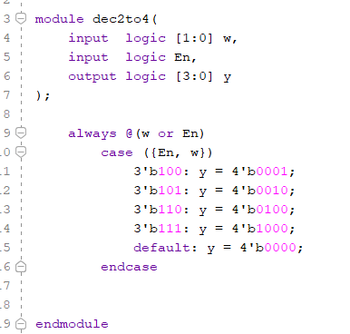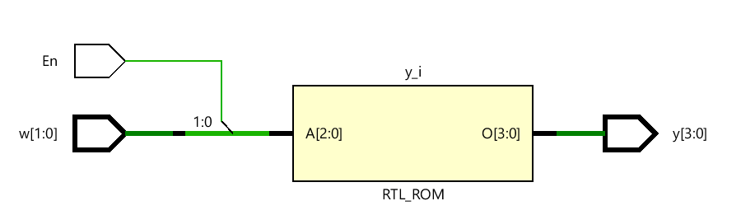

5.1.2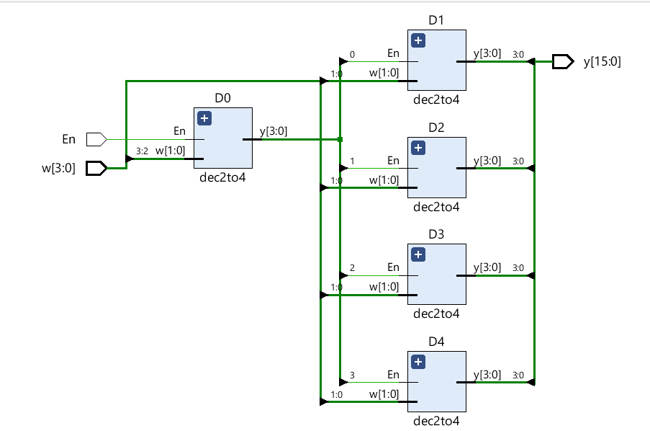

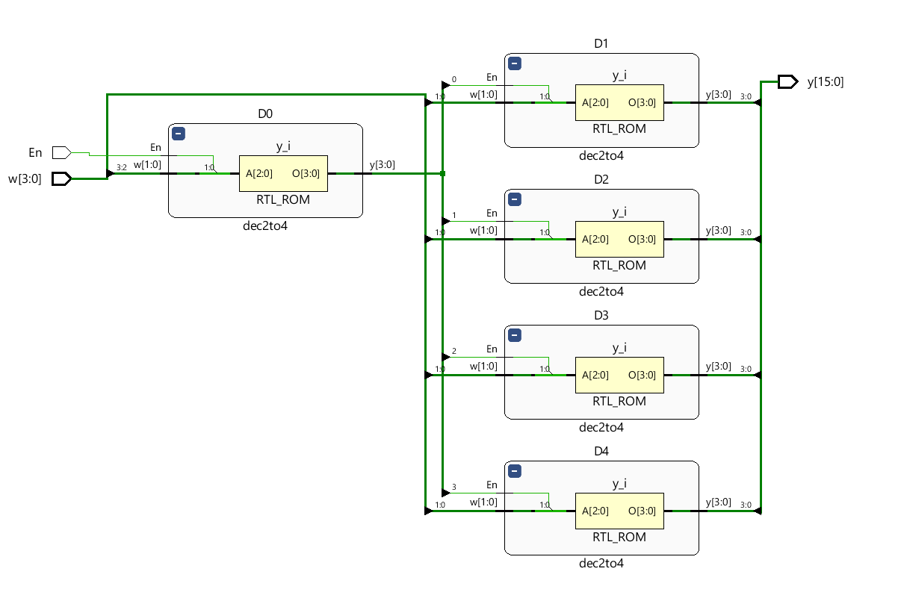

5.1.3
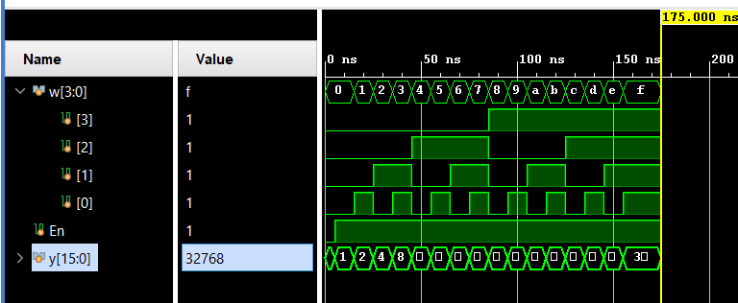

Task #5.2

5.2.1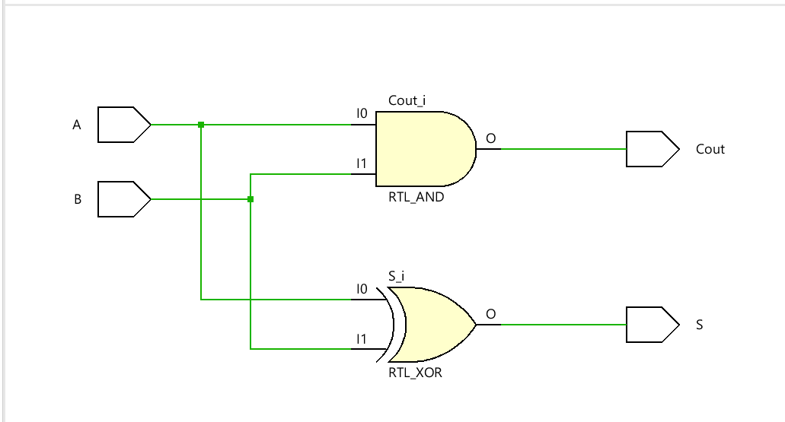
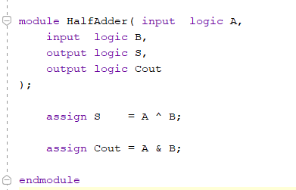
5.2.2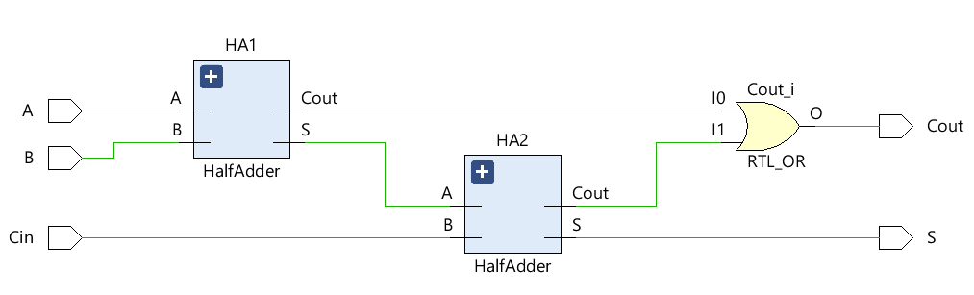

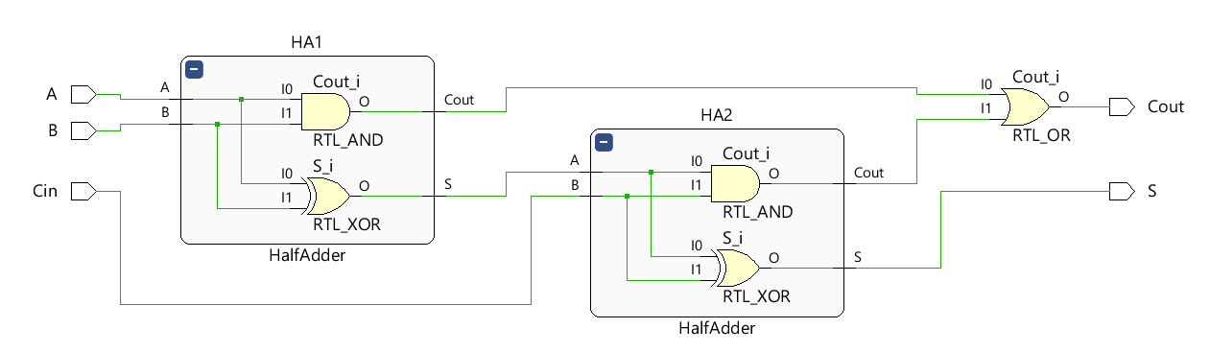

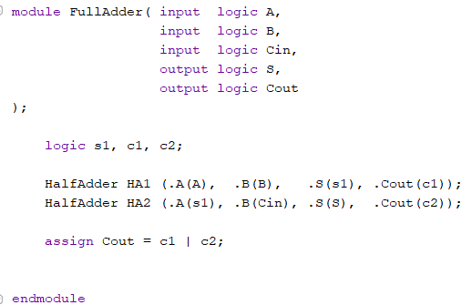

5.2.3

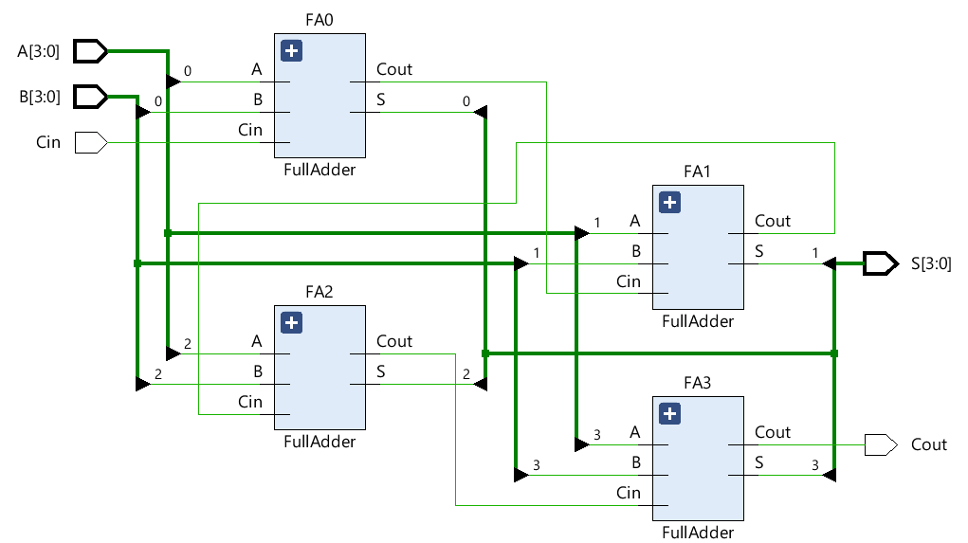

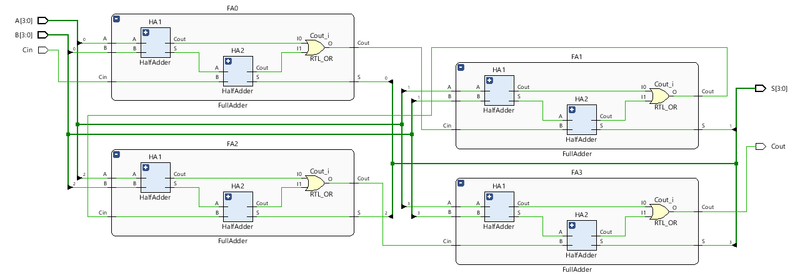

5.2.4

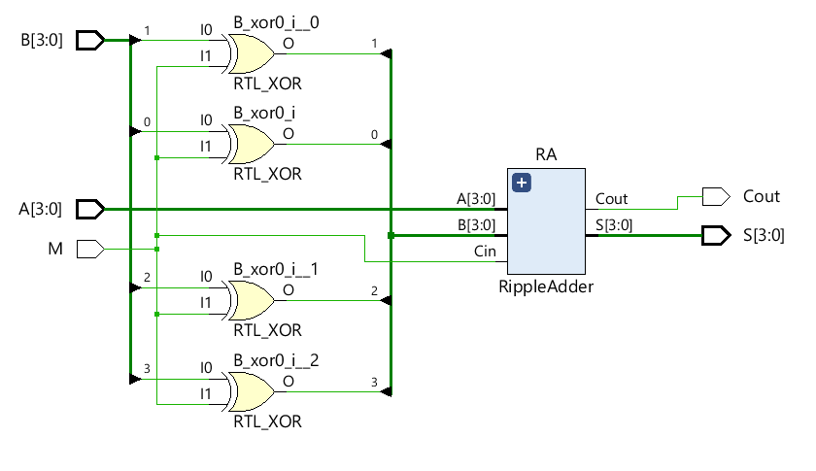

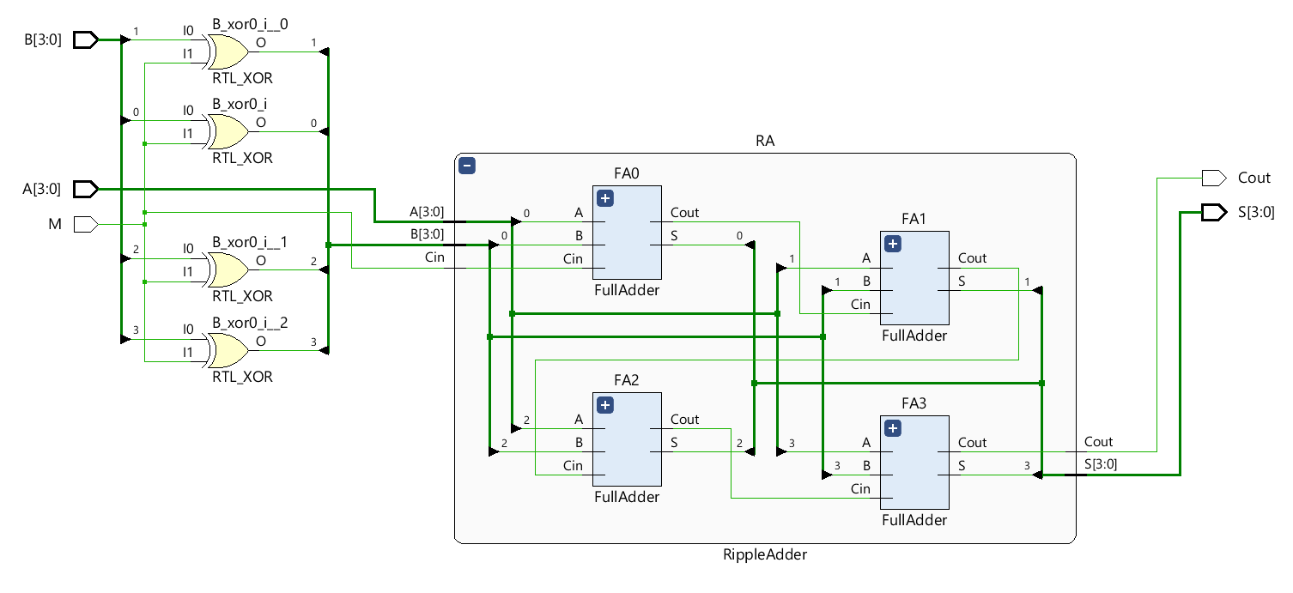

5.2.5

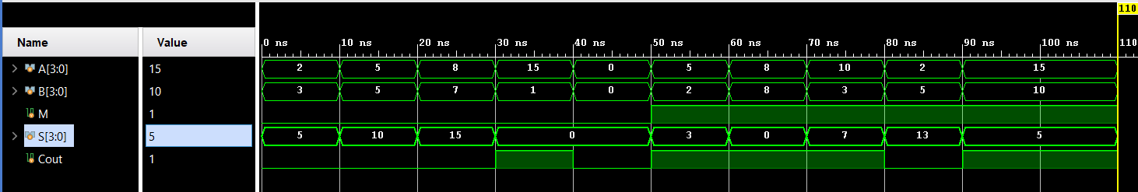

Task #5.3

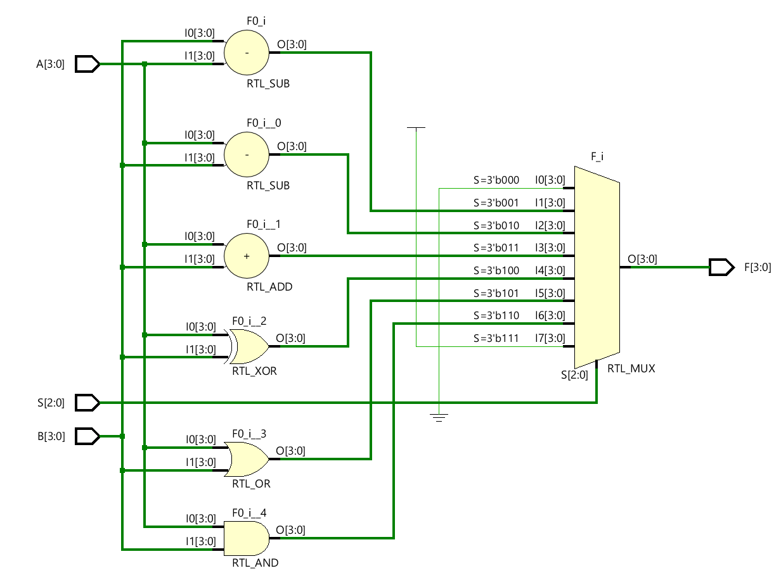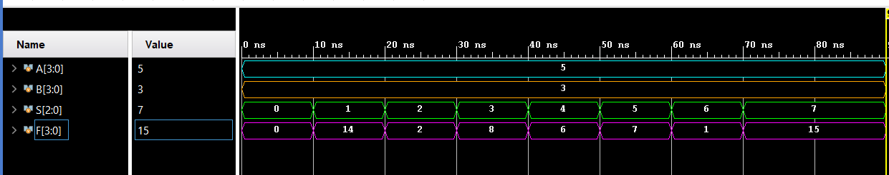

Work distribution

Section | Alia | Elaf | Lana | Manar
Report | ✔ | ✔ | ✔ | ✔
Task n.x | ✔ | ✔ | ✔ | ✔
Task n.x+1 | ✔ | ✔ | ✔ | ✔
Task | ✔ | ✔ | ✔ | ✔

